1 - Baixar o MobaXTerm

<https://mobaxterm.mobatek.net/download.html>

2 - Inserir o arquivo Keymonster.pem na pasta dos Meus Documentos

3 - Abrir o MobaXTerm

4 - executar os comandos abaixo:

cd MyDocumentts

chmod 400 Keymonster.pem

5 - Executar os comandos abaixo:

EAD1

ssh -i KeyMonster.pem hadoop@ec2-18-219-234-184.us-east-2.compute.amazonaws.com

EAD2

ssh -i KeyMonster.pem hadoop@ec2-18-219-234-184.us-east-2.compute.amazonaws.com

6 - Abrir uma nova aba no MobaXTerm

na aba aberta, execute os comandos abaixo:

EAD1

ssh -i KeyMonster.pem -N -D 8157 hadoop@ec2-18-219-234-184.us-east-2.compute.amazonaws.com

EAD2

ssh -i KeyMonster.pem -N -D 8157 hadoop@ec2-18-222-151-209.us-east-2.compute.amazonaws.com

7 - Acessar esse link: <https://chrome.google.com/webstore/category/extensions>

Pesquisar por:  **Proxy SwitchyOmega**

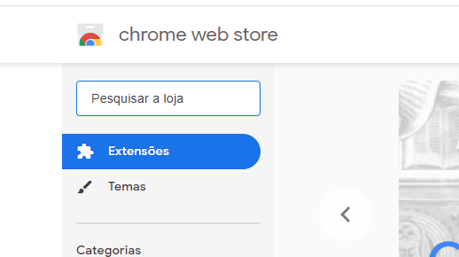

Instalar **Proxy SwitchyOmega**

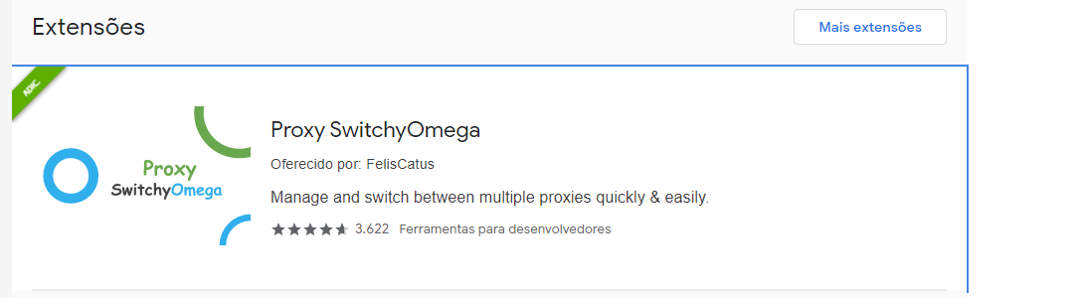

New Profile

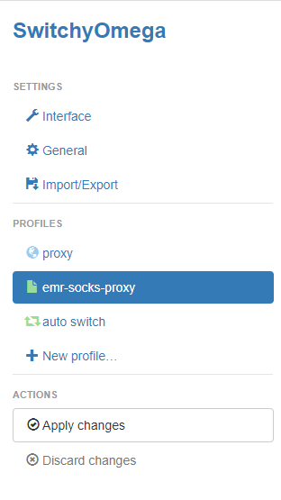

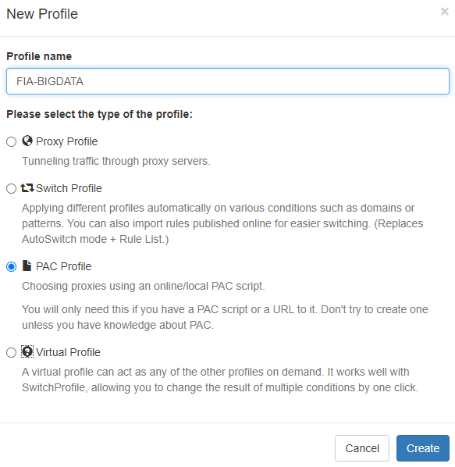

COPIAR E COLAR IGUAL NA IMAGEM ABAIXO:

function FindProxyForURL(url, host) {

if (shExpMatch(url, "*ec2*.amazonaws.com*")) return 'SOCKS5 localhost:8157';

if (shExpMatch(url, "*ec2*.compute*")) return 'SOCKS5 localhost:8157';

if (shExpMatch(url, "http://10.*")) return 'SOCKS5 localhost:8157';

if (shExpMatch(url, "*10*.compute*")) return 'SOCKS5 localhost:8157';

if (shExpMatch(url, "*10*.amazonaws.com*")) return 'SOCKS5 localhost:8157';

if (shExpMatch(url, "*.compute.internal*")) return 'SOCKS5 localhost:8157';

if (shExpMatch(url, "*ec2.internal*")) return 'SOCKS5 localhost:8157';

return 'DIRECT';

}

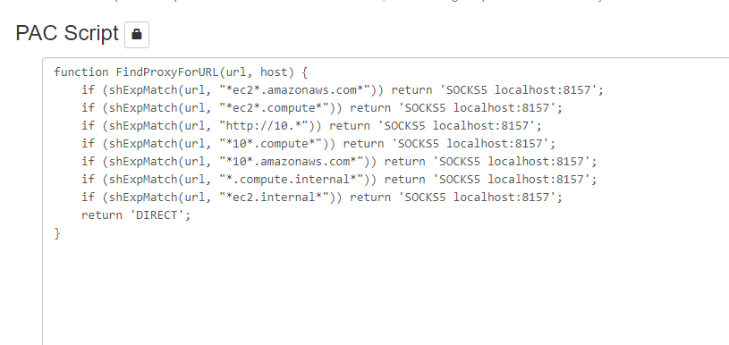

HUE

User: admin

Pass: @Dmin123